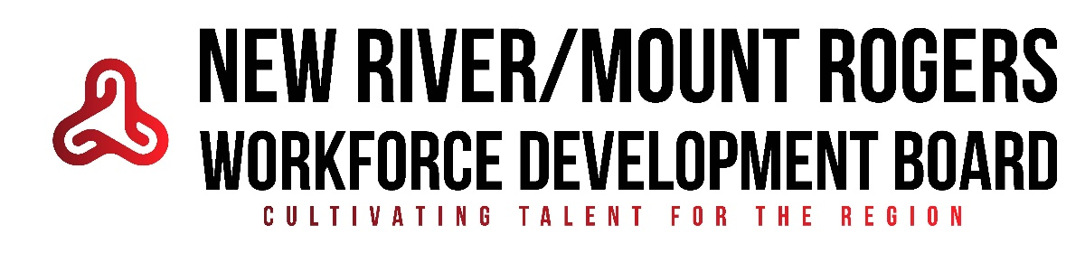

WIOA Quarterly Monitoring Dashboard – PY25
Contractor: People Incorporated of Virginia
Reporting Period: 3rd Quarter Mid Quarter Report PY2025
I. Participant Enrollment & Demographics
Category | Target for PY25 | Quarterly Actual (1/1-2/28) | Cumulative Total | Notes/Variance Explanation
Adult Participants | 121 | 25 | 110 | On Target
Dislocated Worker (DLW) | 37 | 8 | 58 | Met Target
Youth Participants | 51 | 12 | 73 | Met Target
% Served in Each Jurisdiction* | Equitable Access | See Attachment | See Attachment
Individuals with Disabilities | 25% of the total | 2 | 31 (12.91%) | Behind on Target
Minority Participants | 40% of the total | 4 | 40 (16.66%) | Behind on Target
Out-of-School Youth | 75% of youth | 2 | 50 (83.33%) | On target
*Attach a breakdown of participant counts by jurisdiction.
II. Participant Outcomes
Adult:
Outcome Category | Goal | Quarterly Actual | Cumulative Total | Notes/Variance Explanation
Credential Attainment | 78% | 64.86% (24 of 37) | 62.36% (56 of 87) | Below Target
Entered Unsubsidized Employment  2nd Q after Exit | 85% | 70.00% (10 of 13) | 88.57% (62 of 70) | On Target
Entered Unsubsidized Employment  4th Q after Exit | 86.5% | 80.85% (38 of 47) | 80.56%  (87 of 108) | Below target
Measurable Skills Gain | 65% | 46.47% (33 of 71) | 46.47% (33 of 71) | Below Target
Dislocated Worker:
Credential Attainment | 79.47% | 33.33%  (1 of 3) | 77.78% (7 of 9) | Slightly below target
Entered Unsubsidized Employment  2nd Q after Exit | 82% | 66.67% (8 of 9) | 81.82% (18 of 22) | On target
Entered Unsubsidized Employment  4th Q after Exit | 87.8% | 90.00% (9 of 10) | 84.78% (39 of 46) | Slightly below target
Measurable Skills Gain | 65% | 57.14% (12 of 21) | 57.14% (12 of 21) | Below target
Youth:
Credential Attainment | 60% | 63.63% (21 of 27) | 78.46%  (51 of 65) | On target
Entered Unsubsidized Employment  2nd Q after Exit | 78.59% | 72.72% (9 of 9) | 79.63% (43 of 54) | On target
Entered Unsubsidized Employment  4th Q after Exit | 80% | 82.35% (28 of 34) | 78.57% (66 of 84) | Slightly below target
Measurable Skills Gain | 65% | 30.00% (12 of 40) | 30.00% (12 of 40) | Behind on Target
II. Strategic Innovations & Access
Area | Description of Activities This Quarter | Outcome/Impact
Digital Engagement Tools (e.g., Metrix, Conover) | Conover, NorthStar | Youth increase their work-readiness, and all participants enhance their digital skills for employment.
Employer Partnerships / Work-Based Learning | Provided to Kimber in the quarterly business services report
Outreach Efforts | Outreach targeting Community College and public schools | People Inc. has been meeting with the community college workforce development departments – WCC, VHCC, and NRCC, and they have met with Adult Education. Additionally, People Inc. has been reaching out to curriculum/department heads regarding some of our in-demand occupations at community colleges and is beginning outreach/recruitment through public schools.
Cross-Partner Collaboration (e.g., referrals, co-enrollment) | Co-enrollment/partnerships | People Inc. has received an announcement that we will receive a SPARK Energy Grant – they will co-enroll WIOA youth with that grant once it is executed.

IV. Concerns/Technical Assistance Needs

Submitted by Clay Stein: __ Clay Stein_____________________________________
Reviewed by (NRMR WDB Program Manager): ____________________________
Date of Review Meeting: ___________________

