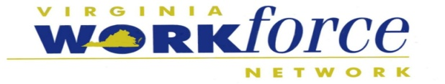

New River/Mount Rogers
Workforce Investment Area

Title: | Incumbent Worker Training Policy | Policy #:
Effective Date: | March 17, 2016 | Revision Date:

References:

Workforce Innovation and Opportunity Act Law – Section 134(d)(4) Virginia Board of Workforce Development Policy #15-00

Purpose:

The purpose of this policy is to describe the use of the Workforce Innovation and Opportunity Act local funds to create incumbent worker training programs.

Policy

Federal Share of Funding:

As defined in federal legislation, up to twenty percent (20%) of WIOA Title I Adult and Dislocated Worker funds allocated to the local area are available to pay for the Federal share of the cost of providing a training program for incumbent workers.

Non-Federal Share of Funding:

Employers participating in the program are required to pay for the non-Federal share of the cost of providing the training to incumbent workers of the employers.
The non-Federal share shall not be less than:
- 10 percent (10%) of the cost, for employers with not more than 50 employees
- 25 percent (25%) of the cost, for employers with more than 50 employees but not more than 100 employees; and
- 50 percent (50%) of the cost, for employers with more than 100 employees

The non-Federal share provided by an employer participating in an incumbent worker training program may include the amount of the wages paid by the employer to a worker while the worker is participating in the training activity. The employer may provide the share in cash or in-kind (the employer must provide documentation of the fair market value).

Employer Eligibility for Funds

Employers must meet the following eligibility requirements in order to qualify for incumbent worker training funds:
- Can identify with one of the target industries for the New River/Mount Rogers area as listed below, or provide justification for funding if the employer does not identify within one of the industries:
  - Agribusiness
  - Biosciences & Medical Devices
  - Business & Financial Services
  - Defense & Security
  - Information Technology
  - Health Services
  - Manufacturing/Distribution;
- Plan to offer a wage increase to training participants within one year of completion of the training program1 ;
- Training must result in an industry-recognized credential, when applicable;
- Have been in operation in Virginia for a minimum of one year prior to application for funding; and have not relocated from another location resulting in layoffs in the preceding 120 days prior to date of application;
- Have at least one full-time employee; and
- Are up-to-date on all state and local tax obligations.

Additional Funding Considerations

Employers submitting applications for Incumbent Worker Training Funds must identify at least one of the following conditions as part of the basis for needing to invest in existing worker training in order to remain competitive:
- Declining sales
- Supply chain issues
- Adverse industry market trends
- Changes in management behavior or ownership
- Phasing out of certain function(s) with the introduction of new function(s) that require worker retraining
- Required skill changes that would otherwise require downsizing, layoffs, etc. if not addressed including, but not limited to
  - Skill changes required by external economic or market forces
  - Significant changes in technology or operating processes
  - Rapidly changing industry or occupational job requirements
  - Emergence of new products.
- New technology and/or equipment implementation
- Creation of new employment opportunities that require advance skills and knowledge
- Other, as deemed applicable by NR/MR WIA Consortium Board and staff

1 Subject to budgetary or funding issues.

Employee Eligibility for Funds

All employees participating in Incumbent Worker Training must meet the eligibility guidelines below. An incumbent worker is:
- At least 18 years of age;
- A citizen of the United States or a non-citizen whose status permits employment in the United States;
- Registered with the Selective Service (If they are a male born on or after January 1, 1960);
- An individual who has an established employment history with the employer for at least 6 months and meets the Fair Labor Standards Act requirements for employer-employee relations; and
- An individual who works at a facility located in Virginia or is working for a staffing agency and placed at a Virginia facility.

Reimbursable Training Expenses

The following activities are eligible for Incumbent Worker Training Funds:
- Training for participants for productive, high demand employment;
- Work-site-based learning strategies using cutting edge technology and equipment;
- Training programs incorporating technological changes in the workplace;
- Training programs designed to impart learning to meet employer-specified or industry-specific skills;
- Train-the-trainer instruction to build the capacity of businesses to effectively respond to the challenges of an increasingly diverse workforce
- Consumable training materials and supplies
- Textbooks
- Off-site facility rental expense directly related to and necessary for the training
- Rental of tools and equipment critical to the project
- Travel expense and per diem of instructor
- Instructor/trainer fees

Non-Reimbursable Costs

The following activities are not eligible for Incumbent Worker Training Funds:
- Costs incurred prior to the approval date of the application
- Construction or purchase of facilities or buildings
- Equipment Purchases
- Business relocation expenses
- Employer or training in sectarian activities
- Lobbying activities
- Direct employee wages (though they can be contributed toward in-kind non-Federal share)

Application Process

Employers interested in receiving funding for incumbent worker training must complete the WDB’s Incumbent Worker Training Application. This should be returned to Marty Holliday, Executive Director at marty.holliday@nrmrwib.org. Any questions pertaining to the application can be directed to Ms. Holliday at her email address or via telephone at (540) 633-6764.
WDB staff will be responsible for reviewing the applications submitted on a first-come, first-serve basis for access to funding. Once the application has been reviewed, a site-visit may or may not be conducted to request additional information or to review facilities for training eligibility.

Once approved for funding for Incumbent Worker Training, the employer must submit the following documents, which can be found in the Incumbent Worker Training Funding Packet. These documents must be completed before reimbursement will be issued:
- Employee Eligibility Documentation Form (includes Name, Gender, Social Security Number, and Date of Birth, Job Title and Wage for each participating employee);
- Grievance & Complaint Procedures and EEO Notification Form; and
- Employer Certification

At the completion of the incumbent worker training, certificates of completion or copies of the credentials of each trainee must be provided to the WDB for performance metrics.

The Incumbent Worker Training program is a reimbursement program. The employer must pay for the training prior to asking for reimbursement from the WDB. Reimbursements will be made to the employer within 60 days of receipt of the following documents:
- A copy of the invoice from the training provider;
- A copy of the payment check to the training provider for the incumbent worker training;
- A completed Reimbursement Request Form; and
- A completed Training Course Evaluation Form

Approval Process

Proposals will be considered on a first-come, first-serve basis from the date of submission of the Incumbent Worker Training Application to WDB staff. WDB staff will make a determination based on the availability of funds for incumbent worker training. If funding is not available, the employer will be placed on a wait list for when funding is available to the local area.

Follow-Up Process

Follow-up with each employer approved for incumbent worker training will occur for one year following the training end date. Quarterly contact will be made with the employer to verify the following information regarding the employees who received incumbent worker training:
- The employment status of all employees who received incumbent worker training
- The employees’ wage
- The employees’ job title
- Any additional information that was not collected during the training period

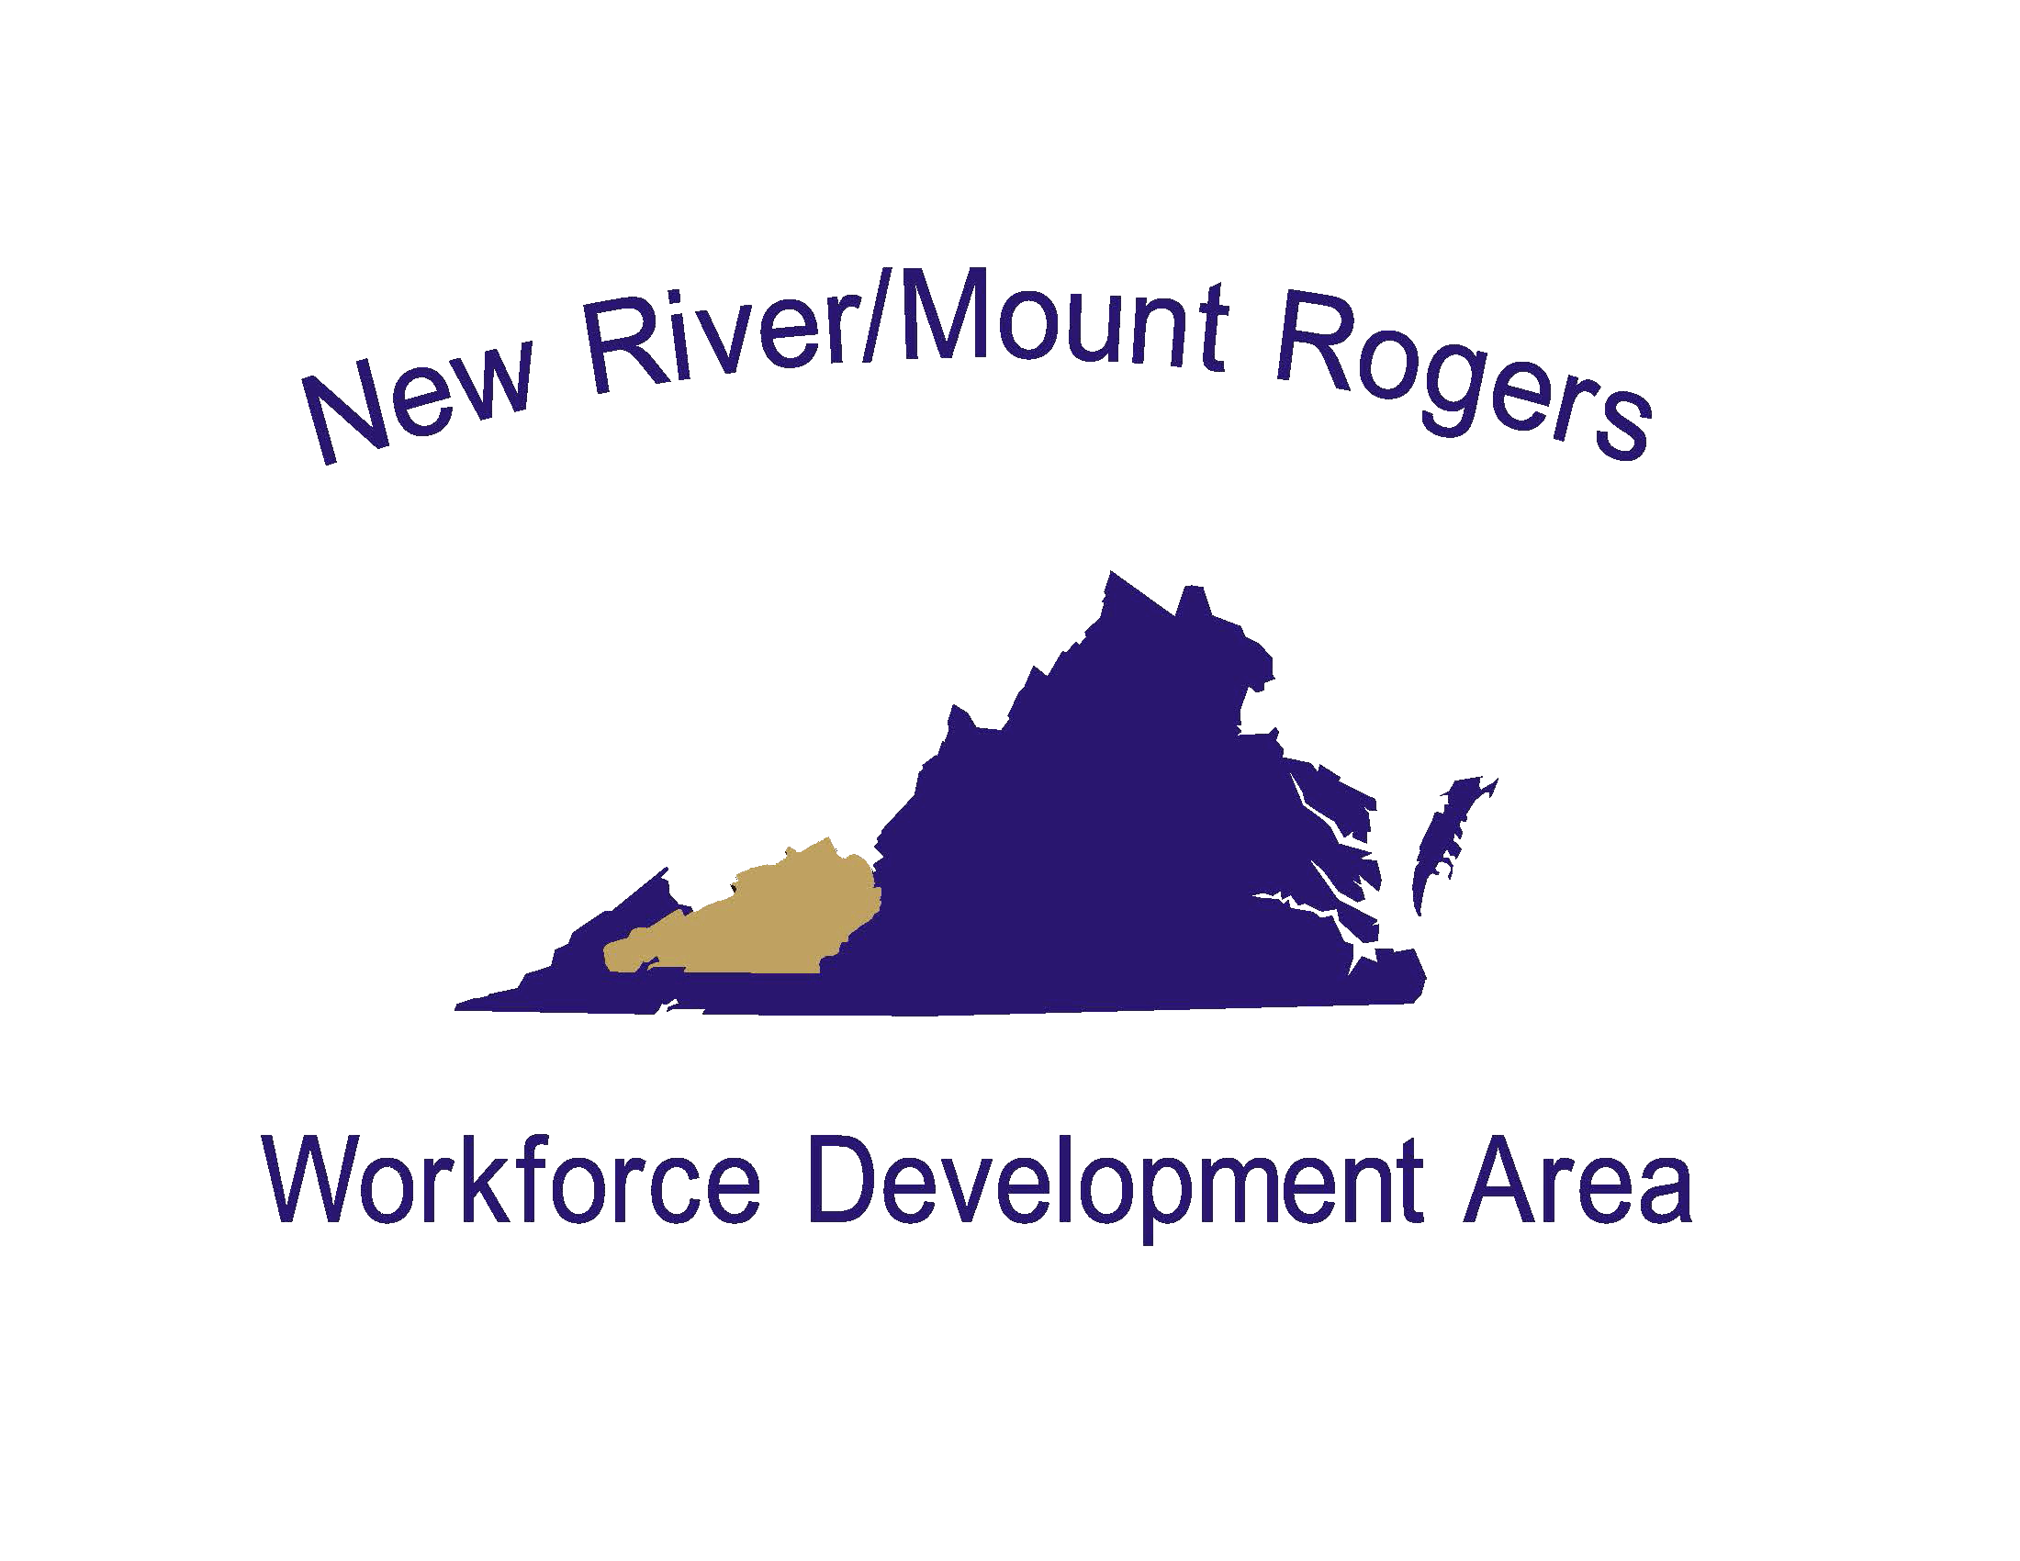


New River/Mount Rogers Workforce Development Board
Incumbent Worker Training Funds Application

Section 1: Company Information

Please check the target  industry that your  organization falls under: | Health Services  Information Technology  Business and Financial Services  Agribusiness  Bioscience and Medical Devices  Defense and Security  Transportation and Logistics  Manufacturing  Other (specify):

Parent or Corporate Name of Applying Company (As Listed on IRS W9 Form):
Physical Address:
City: |  |  | State: |  | Zip:
P.O. Box Address:
City: |  |  | State: |  | Zip:
Company Name, if Different:
Physical Address:
City: |  |  | State: |  | Zip:
P.O. Box Address:
City: |  |  | State: |  | Zip:

Company Contact: |  | Title:
Phone: |  | Email:

Federal ID Number: |  | Date Business Began in Area:
Number of Full-Time Workers: |  | Number of Part-Time Workers:
Tax Status of Business: | For-Profit Not-For-Profit (Designation Other
Legal Structure of Business: | Sole Proprietor Partnership  Limited Liability Company Corporation
Is your company current on all Federal, State of Virginia, County, City and Local Tax Obligations? |  | Yes No
Is your company receiving and/or applying for other public training funds? |  | Yes No
If yes, explain:

Does your company have an equal opportunity/nondiscrimination policy in place? |  | Yes No
Is your company subject to a collective bargaining agreements? |  | Yes No
If yes, and if union represented employees will be participating in the training activities of this program, it is required that consent be obtained from the representing union to collect the eligibility data from the employees PRIOR to funding approval.
Is your company willing to provide project outcome information to the Workforce Development Board? |  | Yes No
This company is:  (check all applicable) | Native-American Owned Asian-American Owned  African-American Owned Woman Owned  Hispanic-American Owned Other Minority Owned
Please provide a brief description of your business, product(s) and/or service(s):

Section 2: Training Provider Information
(attach additional sheets, if necessary)

Training Provider(s) will be: | Public Training Institution Private Training Institution  Company Instructor
Training will be Delivered: | On-Site at the Business At the Training Institution  At a Remote Location

Training Provider:
Contact Name: |  | Phone:
Physical Address:
City: |  | State: |  | Zip:

Section 4: Needs Identification

Indicate which challenge(s) would be addressed by the proposed training.
(Check all that apply; at least one must be identified for funding consideration)

Declining Sales
Supply Chain Issues
Adverse industry market trends
Changes in management behavior or ownership
Phasing out certain function, introducing new functions/lines that require worker retraining
Required skill changes that would otherwise require downsizing, layoffs, etc. if not addressed
New technology and/or equipment implementation

Creation of new employment opportunities that require advance skills and knowledge
Other: (specify)

Section 5: Training Project Information

Please describe your organization’s challenges that would be addressed by the proposed training.

What credential, if applicable, will the individuals receive from the proposed training?

What are the job titles and average salaries for the individuals that would receive the proposed training?

How will this training make the participant and your organization more competitive in this economy?

What is the potential for wage increases at the completion of the training and/or within one year of training end date?

How will this training allow the participating individuals to retain their employment?

Section 6: Training Program Budget

This section must be completed to show use of proposed training funds and employer match contributions. Please provide specified training information and itemize completely.

A. Budget Category | B. Requested Funds | C. Employer Contribution | Sub-Total (B+C)
Non-Company Instructor Fees or Tuition Costs
 |  |  | $
Training Related Rentals (facilities, equipment, tools, etc.)
 |  |  | $
Materials/Supplies/Textbooks
 |  |  | $
Other Costs (Describe)
 |  |  | $
Travel/Food/Lodging For Instructor(s) Only
 |  |  | $
Trainee Wages (Including Benefits)
 | Incumbent Worker Training Funds Cannot be Used (Can be counted as in-kind match for employer contribution) |  | $

Section 7: Incumbent Worker Training Funds Requested

Training Funds Requested: | $
Number of Employees to be Trained:
Proposed Training Start Date:
Anticipated Training End Date:
(Maximum of 12 months from proposed start date)

Signature and Certification
By my signature, I verify the information in this application is accurate to the best of my knowledge and I have the authority to submit this application on behalf of the named employer. I also certify that I have read the New River/Mount Rogers Workforce Development Board’s Incumbent Worker Training Policy and agree to all of the terms and conditions outlined in that policy.

Signature: | Date:
Name:
Phone/email:

NR/MR Workforce Investment Area Consortium Board / NR/MR Workforce Development Board is an equal opportunity employer/program. Auxiliary aids and services are available upon request to individuals with disabilities. TDD/TTY: 711. Funded by the U.S. Department of Labor.




Employee Eligibility Documentation

Name | Gender | S.S. Number | Date of Birth | Job Title | Wage

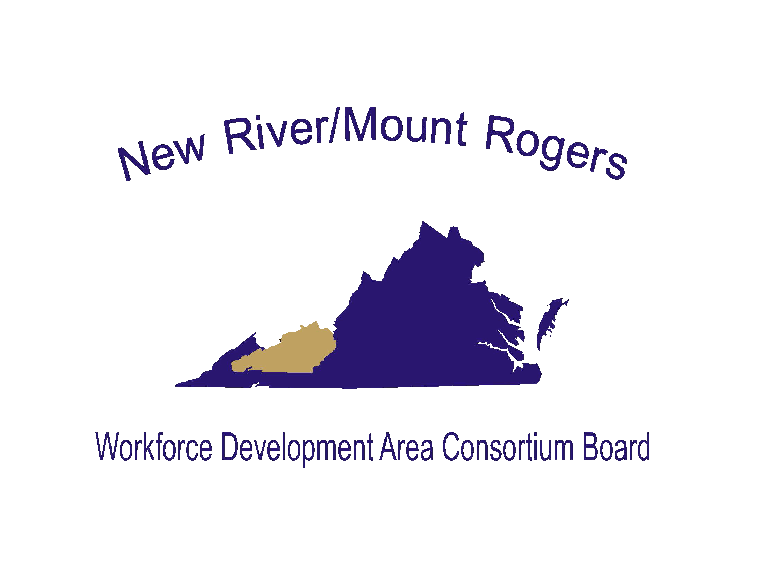

Grievance & Complaint Procedures and EEO Notification

By signing below, I hereby certify that I have the authority to provide signature on behalf of

I also certify that I have received the following documents from the New River/Mount Rogers Workforce Development Board:
- Incumbent Worker Training Policy
- Grievance and Complaint Procedures
- Equal Opportunity Notification

Signed:
Printed Name:
Job Title:
Date:

New River/Mount Rogers Workforce Development Board

Local Workforce Development Area 2 (LWDA 2) Grievance and Complaint Procedures

The grievance and complaint procedures for the New River/Mount Rogers Workforce Development Board (“NR/MR WDB”) apply to alleged violations of the requirements of the Workforce Innovation and Opportunity Act (WIOA). These grievances or complaints may be submitted by participants and other interested parties affected by the NR/MR WDB system, including one-stop partners and service providers.

Filing a Grievance or Complaint
All grievances or complaints must be submitted in writing to the NR/MR WDB Executive Director at the following address:

Marty Holliday, Executive Director
New River/Mount Rogers Workforce Development Board
6580 Valley Center Drive, Suite 119
Radford, VA 24141
OR;
Grievances or complaints may be submitted directly with the U.S. Equal Employment Opportunity Commission at the following address:

Director, Civil Rights Center
U.S. Department of Labor
200 Constitution Avenue, N.W. Room N-4123 Washington, D.C. 20210
(202) 219-8927

Examples of who may file a grievance or complaint include the following:
- Applicants and/or registrants for aid, benefits, services or training
- Eligible applicants/registrants
- Participants
- Employers
- Applicants for employment under WIOA
- Service providers
- Eligible service providers

Each grievance or complaint must be filed, in writing, within thirty (30) calendar days of the alleged situation and must contain the following information:
- The name, address, email and telephone number of the person filing the grievance or complaint;
- The date of the alleged situation and the date the grievance or complaint was filed;
- The identity of the respondent (i.e. the individual or entity against whom the grievance or complaint is alleged);
- A description of the allegation(s). This description must include enough detail to allow the reviewer to decide whether the allegation(s), if true, would violate any of the provisions of WIOA; and
- The signature of the person filing the grievance or complaint.

Methods of Resolution/Disposition of Complaints
The reviewer will provide, within ten (10) business days of receipt, written notice to the grievant or complainant that the grievance or complaint has been received. Such notice will include:

- A summary of the allegation(s) submitted;

- A notice that the Executive Director may arrange for an informal resolution to the complaint prior to the an official meeting or hearing;
- A proposed date, time and place of the meeting or hearing with the reviewer.
- A notice that the grievant or complainant may be represented by an attorney; and
- A notice that the grievant or complainant may present witnesses and documentary evidence.

The Commonwealth of Virginia’s discrimination complaint process includes sixty (60) days for the WDB Executive Director to investigate and thirty (30) days for a review at the State level, if warranted. If the complainant files with both the WDB Executive Director and the DOL Civil Rights Center (CRC), the complainant shall be informed that the WDB Executive Director has 90 days to process the complaint and that CRC shall not investigate until the 90 day period has expired.

Notice of Final Action
Once the investigation is complete and a decision has been reached, a Notice of Final Action must be sent to the grievant or complainant. If an informal resolution was provided, the Notice of Final Action must summarize the resolution agreed upon. If no informal resolution was provided, the Notice of Final Action must contain the following information:

- The reviewer’s decision and the reasons supporting the decision;
- A brief description of the investigation process implored to reach the decision;
- A notice that, if no decision is reached within sixty (60) days or if dissatisfied with the decision, the grievant or complainant may appeal to the Commonwealth of Virginia within ten (10) business days of receipt of the Notice of Final Action; and
- A notice that the grievant or complainant may seek a remedy authorized under another Federal, State or local law.

A complaint may be filed with the CRC within thirty (30) days of receiving the Notice of Final Action.

Record Keeping Requirements
Records regarding grievances and complaints must be maintained for at least three (3) years from the date of resolution of the grievance or complaint. All records must include the following:

- The name and address of the grievant or complainant;
- A description of the grievance or complaint;
- The date the grievance or complaint was filed;
- The disposition (final action);
- The date of disposition of the grievance or complaint; and
- Any other pertinent information.

To the maximum extent possible, the identity of any person who has furnished information relating to, or assisting in, an investigation of a possible violation of the WIOA shall be kept confidential. The information may only be used for purposes of:

- Record keeping and reporting;
- Determining the extent to which an entity is operating its WIOA funded programs or activities in a nondiscriminatory manner; or
- Other use authorized by the nondiscrimination and equal opportunity provisions of WIOA.

EQUAL OPPORTUNITY (EO)/ CIVIL RIGHTS NOTIFICATION

Equal Opportunity is the Law.
It is against the law for this Workforce Innovation and Opportunity Act (WIOA) Service Provider to discriminate on the following basis:
- Against any individual in the United States, on the basis of race, color, religion, sex, national origin, age, disability, political affiliation or belief; and
- Against any beneficiary of programs financially assisted under Title I of the Workforce Innovation and Opportunity Act of 2014 (WIOA), on the basis of the beneficiary’s citizenship/status as a lawfully admitted immigrant authorized to work in the United States, or his or her participation in any WIOA Title I, financially assisted program or activity.
The WIOA Service Provider must not discriminate in any of the following areas:
- Deciding who will be admitted, or have access, to any WIOA Title I, financially assisted program or activity;
- Providing opportunities in, or treating any person with regard to, such a program or activity; or
- Making employment decisions in the administration of, or in connection with, such a program or activity. What to Do if you Believe You Have Experienced Discrimination by the WIOA Service Provider:
- If you think that you have been subjected to discrimination under a WIOA Title I-financially assisted program or activity, you may file a complaint within 180 days from the date of the alleged violation with either:
  - The Local Workforce Development Board’s (LWDB) Equal Opportunity (EO) Officer: Marty Holliday, Executive Director for the New River/Mount Rogers Workforce Development Board, 6580 Valley Center Dr., Suite 119, Radford VA 24141; 540-633-6764, Virginia Relay Users call 711; or
  - The State WIOA Equal Opportunity Officer: Vicki Tanner, State WIOA Equal Opportunity Officer for the Virginia Community College System, Arboretum III, 300 Arboretum Place, Suite 350, Richmond, VA 23236, 804-819-1682
  - The Director, Civil Rights Center (CRC), U.S. Department of Labor, 200 Constitution Avenue, NW, Room N-4123, Washington, DC 20210.
If you file your complaint with the LWDB EO Officer, you must wait until either the LWDB EO Officer issues a written Notice of Final Action, or until 90 days have passed (whichever is sooner), before filing with the Civil Rights Center (see address above). If the LWDB EO Officer does not give you a written Notice of Final Action within 90 days of the day on which you filed your complaint, you do not have to wait for the LWDB EO Officer to issue that Notice before filing a complaint with CRC. However, you must file your CRC complaint within 30 days of the 90-day deadline (in other words, within 120 days after the day on which you filed your complaint with the recipient).

If the LWDB EO Officer does give you a written Notice of Final Action on your complaint, but you are dissatisfied with the decision or resolution, you may file a complaint with CRC. You must file your CRC complaint within 30 days of the date on which you received the Notice of Final Action.

FOR MORE INFORMATION OR TO FILE A COMPLAINT, CONTACT
Vicki Tanner, State WIOA Equal Opportunity Officer Workforce Development Services
Virginia Community College System Arboretum III
300 Arboretum Place, Suite 350
Richmond, VA 23236
(804) 819-1682

New River/Mount Rogers Incumbent Worker Training Program

Reimbursement Request Instructions
- The reimbursement request should be emailed to the New River/Mount Rogers Workforce Development Board by a company representative.
- The reimbursement request should include the following documentation:
  - A copy of the invoice from the training provider
  - A copy of the check showing that the invoice balance was paid in full
  - A copy of the Reimbursement Request Form
- The reimbursement request must be submitted no later than 30 days after the last training date listed on the Reimbursement Request Form.
- Before a reimbursement is distributed, a completed Incumbent Worker Trainee Form must be filled out and returned to the Workforce Development Board for each employee who completed retraining.
- The reimbursement request must also be accompanied by a completed Training Evaluation Form filled out by the company upon the conclusion of the retraining efforts.

Reimbursement requests shall be submitted to:
Marty Holliday
New River/Mount Rogers Workforce Development Board
6580 Valley Center Drive, Suite 119
Radford, VA 24141
Email: marty.holliday@nrmrwib.org
Fax: (540) 633-2502
Questions? (540) 633-6764

**Please note that reimbursements may require 45-60 days for processing and distribution**

New River/Mount Rogers Workforce Development Board
Incumbent Worker Training Program - Reimbursement Request Form

Date of Request:
Company Name: Company Address:

Federal ID#: Number of Employees:

Training Provider: Dates of Training: Program of Study: Completion Date:

# | Name | Wage | Job Title
1
2
3
4
5
6
7
8
9
10
11
12
13
14
15
16
17
18
19
20

I certify that the above employees have completed the company’s retraining effort and are currently employed by the company.

Signature: Title:
Date:

New River/Mount Rogers Workforce Development Board
Course Evaluation Form

Company Name: | Date:
Supervisor Name: | Department:
Program of Study: | Start/End Date:

Please rate the following criteria regarding your Incumbent Worker Training experience.

 | Strongly Agree | Agree | Neutral | Disagree | Strongly Disagree
My staff is better able to perform their jobs because of the skills acquired in the training course.
I have noticed an improvement in staff performance.
My staff has been using the knowledge, skills, and abilities learned in the training in performing their job.
As a result of the training, I feel that my staff is prepared to take on more responsibility.
Attending the training has improved my staff’s motivation at work.
It would be useful to my organization to continue this type of training.
The course location was convenient for my staff.
The course schedule was convenient for my staff.

Please list any material not covered in this specific course that you would like to see added or additional training you would like to see offered to your staff in the future.

Please share any “Success Stories” you may have as a result of this training.

Signature:

Title:

