  - New River/Mount Rogers Workforce Investment Area
Consortium Board

MEETING MINUTES
May 18, 2016

A meeting of the NR/MR WIA Consortium Board was held on May 18, 2016 at the Crossroads Institute in Galax, VA. Those in attendance were as follows:

Board Members | Guests
Catherine Brillhart – Chair  Andy McCready – Vice-Chair  Dr. Eric Workman – Bland  Rex Hill – Carroll  Brenda Sutherland – Grayson  Terri Morris - Floyd  Mary Biggs - Montgomery  John Garner – Galax City | Lynn White, WDB Chair  Darrell Blankenship – People Inc.  Beverly Amburgey – Goodwill Ind. of the Valleys  Kevin Byrd – NRVRC  Josh Lewis – VA’s A Corridor  Aaron Sizemore - MRPDC  Staff  Marty Holliday  Ronnie Martin  Beverly Burke

At 10:00 AM, Chair Brillhart called the meeting to order. The meeting was opened with a moment of reflection with a remembrance of the passing of Mike Rouse who served on the WDB. All present recited the Pledge of Allegiance which was led by Chair Brillhart.

Chair Brillhart asked for everyone to introduce themselves since several new Board members were present.

Chair Brillhart asked Ms. Burke to call the roll. A quorum was present.

Chair Brillhart next asked for a motion to approve the Consent Agenda items that had been previously distributed. Dr. Workman made a motion to approve the Consent Agenda items.

  - Meeting Minutes from the March 16, 2016 Meeting
  - Approval of WDB Reappointments
  - Approval of New WDB Appointments
  - Approval to Extend M. Holliday’s Excess Leave Time to August 30, 2016

Ms. Biggs seconded the motion which was unanimously approved.

Chair Brillhart opened the floor to public comment. There was none.

Kevin Byrd of the New River Valley Regional Commission gave an overview of the Go Virginia Program. A brief discussion followed concerning the possibility of a split in the Planning Regions which could affect the Area II Workforce Region.

Ms. Holliday requested that the Board approve a recommendation from the Personnel Committee to increase all full-time staff wages 3% effective July 1, 2016, with the exception of Ms. Burke who is getting a 5% increase due to her Apprenticeship and increased job duties. Mr. McCready made the note, that staff will be absorbing additional insurance cost and he wanted the Board to be aware of this situation. Mr. McCready made a motion to accept the recommendation of the Personnel Committee, Dr. Workman seconded the motion which was unanimously approved.

Mr. Martin requested that the Board approve the Fiscal Agent Agreement Extension with the New River Valley Regional Commission. The NRVRC has handled the Board’s finances from the beginning and the arrangement has worked well. This Fiscal Agent Agreement is being extended for a one-year period. Dr. Workman made a motion to extend the Fiscal Agent Agreement for one year. Ms. Sutherland seconded the motion which was unanimously approved.

Chair Brillhart next asked for a motion to approve the PY16 Funding Recommendation from the One-Stop Committee and Youth Committee. Mr. McCready made a motion to approve the funding recommendations as presented by the committees. Ms. Biggs seconded the motion which was unanimously approved, Chair Brillhart abstained.

Dr. Workman, chair of the Nominating Committee, stated that Chair Brillhart did not run for reelection and that her term would be ending June 30, 2016. Given that information, the Nominating Committee is recommending that beginning July 1, 2016 that John Garner be Chair of the NR/MR Workforce Investment Area Consortium Board. He also told the members that an Executive Committee vacancy (from the Mount Rogers Planning District) was also created and that the Nominating Committee is recommending that Brenda Sutherland be appointed to fill this vacancy on the Executive Committee. The floor was opened for additional nominations, hearing none, the floor was closed with a motion from Mr. McCready. Committee Chair Dr. Workman made a motion on behalf of the Nominating Committee to approve the above recommendations. The motion was unanimously approved. Dr. Workman told the members that Chair Brillhart added Ms. Biggs to the Nominating Committee (and had removed John Garner prior to the nomination process).

Mr. White, WDB Chair, thanked everyone for the appointments and the approval of all recommendations. He stated that the Rapid Response plan has been submitted and that Ms. Holliday would update the Board later on the details. He informed the Board that we are still operating without final federal regulations.

Chair Brillhart asked Mr. Martin to give an Operational Summary. Mr. Martin reviewed service levels and stated that the Program Operators are in line with their planned service goals. Mr. Martin informed the Board that although DLW placement levels are down, it is due to the fact that several TAA clients, who retired, were taken off the program as no additional Program Services were needed. Information is through April 30 except for financials which are through March 31, 2016. He will be watching Adult monies closely so that the Program Operators will be able to maintain services until PY16 monies arrive.

Chair Brillhart asked Ms. Holliday to give an Executive Summary. Ms. Holliday updated the Board on Staff activities, business engagement, and outreach since their last meeting. Ms. Holliday informed that Board that Kimber Simmons is now a Certified Work Incentive Practitioner and will be able to provide services to DARS clients. Ms. Holliday will be representing the Board in Orlando, FL at the NAWDP Conference where she will be conducting a workshop.

Continuing with the agenda, Chair Brillhart proceeded with the Informational Items. Ms. Holliday briefly discussed the following topics:

- Reviewed Quarterly Workforce Report, Q1 2016. VA Tech Office of Economic Development has prepared this report which will be provided quarterly. Each quarter a different industry will be highlighted.
- Reviewed Draft Demand Occupations List. This list is needed for the Approved Training Provider Policy and Process (used when Adult and DLW participants are sent to training using WIOA funds).
- Reviewed Draft Incumbent Worker Policy. This is an initial review. The WDB will also have an opportunity to review and comment on this Policy. Both Boards will need to approve the policy in July and August respectively.
- Rapid Response Implementation Plan has been submitted. Staff is working with the State to finalize the details of the plan.
Mr. Blankenship, updated the Board on the One Stop Operator report and the Just Hire One Adult Re-entry Project. Ms. Amburgey shared the Success Story and updated the Board on Goodwill’s Just Hire One Adult Re-entry Project.

Ms. Holliday updated the Board on current Grants.

Chair Brillhart opened the floor for Consortium Board Members comments but there were none.

The next meeting will be on June 20, 2016 at the Wytheville Meeting Center in Wytheville beginning at 10:00 AM.

With no further business to discuss the meeting was adjourned at 12:02 am.

Respectfully Submitted,
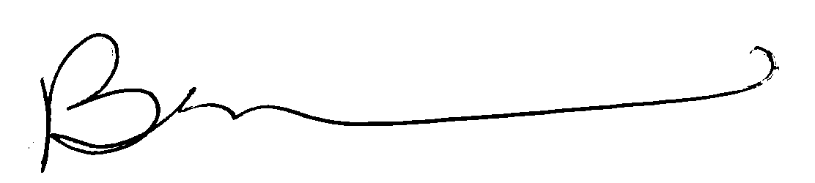

Beverly Burke
Workforce Operations Coordinator

